# HeidiSQL On Linux Installation Guidelines

This document consists of guidelines for installing HeidiSQL on Linux for the ["Databases Basics - MySQL" course @ Software University.](https://softuni.bg/courses/databases-basics-mysql)

Since HeidiSQL native is a windows application, it can be installed on Linux using the **Wine Software**.

### Step 1. Download Wine

Running the following command will start the installation of Wine:

**sudo apt-get install wine**

Following the instructions. You will need to accept a license agreement for TrueType fonts. Use the arrow keys → , ← and “Enter” to operate.

### Step 2. Download the HeidiSQL installation file

Download the installer from <http://www.heidisql.com/download.php>.

### Step 2. Open the Wine Program Installer

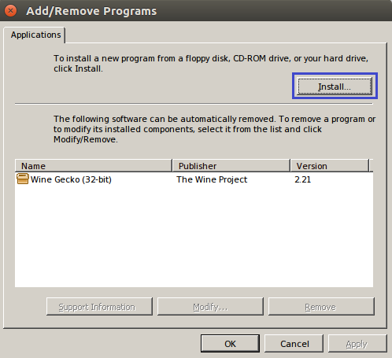

Click the “**Install**” button and **select the HeidiSQL file** that you’ve earlier **downloaded**.

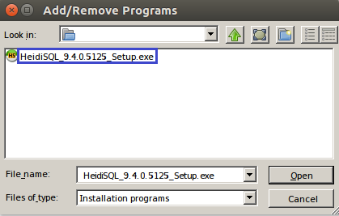

**Follow the installation steps by clicking “Next” button.**